ASSIGNMENT 2
Name : SHASHWATH S SHETTY
Class : 3C
USN : ENG25CY3003
DATE : 27/09/2025

- What does the command pwd, whoami, and hostname display?
Soln:
The pwd command prints the full path of your current working directory.
Syntax: pwd [options]
Options:
-L → prints shortcuts if available
–P → prints exact canonical path.

- Write the command to create a directory named “project” inside the /home/student folder and keep three .txt file into it. Give output snapshot.
Soln:
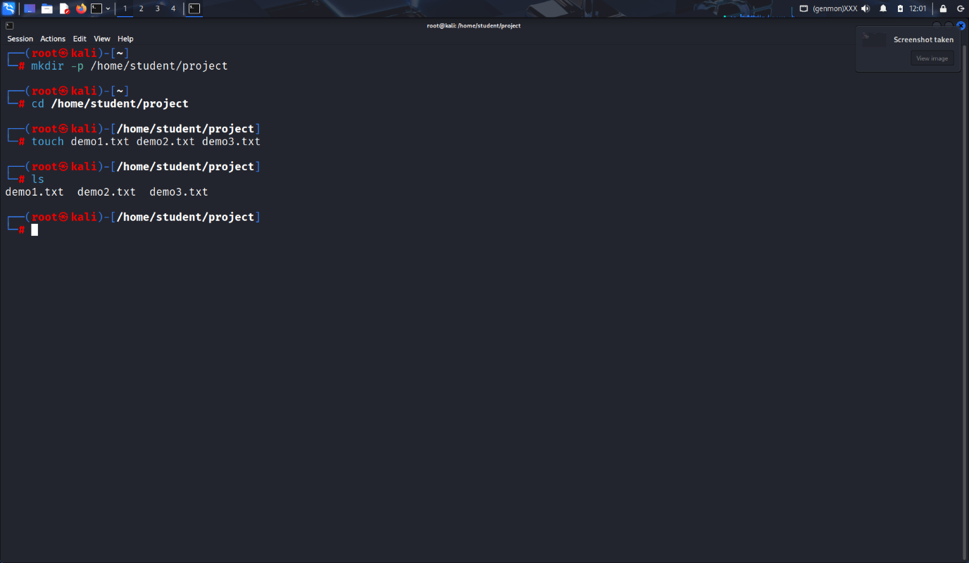
- Explain the difference between absolute path and relative path with proper examples
Soln:
Absolute Path: Complete path starting from root (/).
Example: /home/student/project/file1.txt
Relative Path: Path relative to the current working directory.
Example: If you are already inside /home/student, then project/file1.txt.

- What command will give you the already executed command traces in the terminal. Give output snapshot.
Soln:
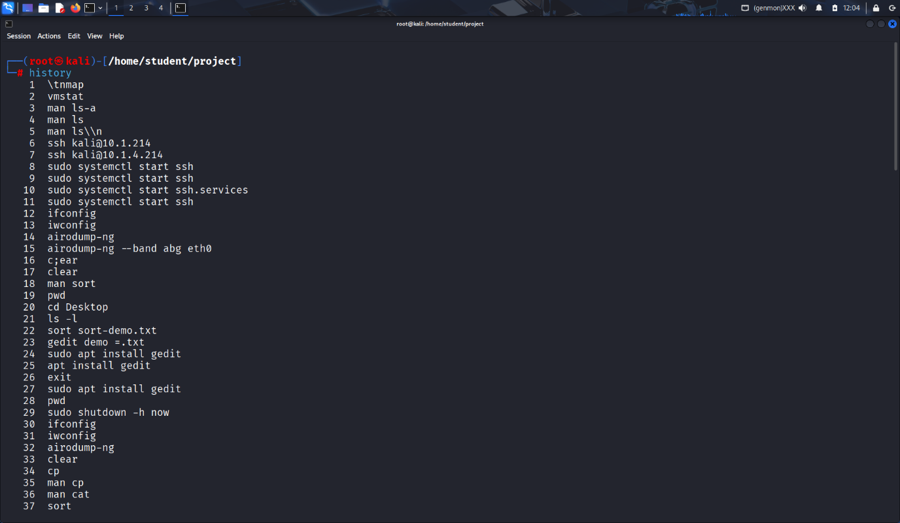
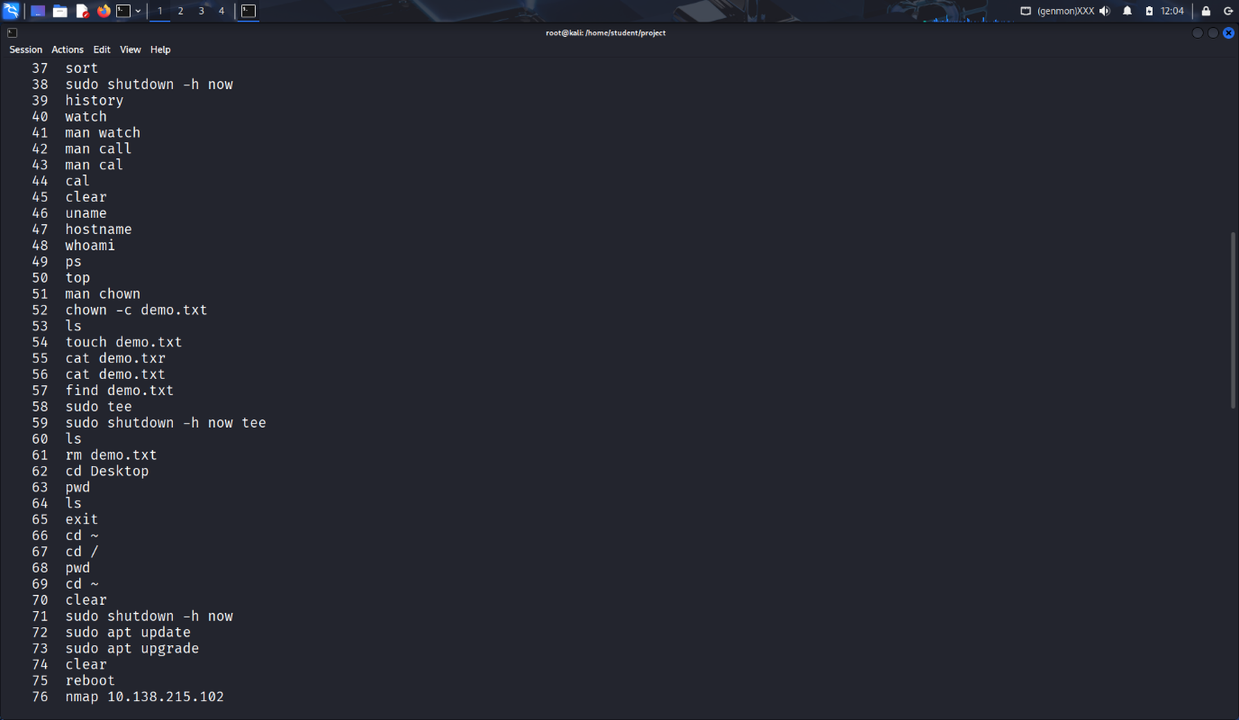
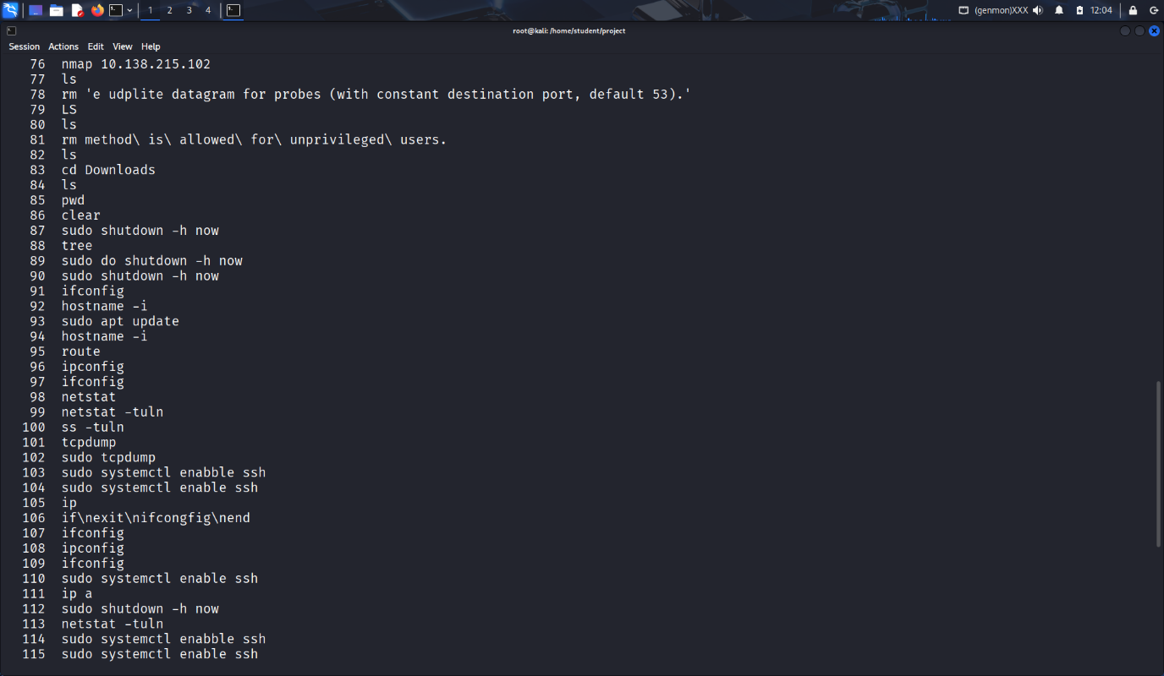
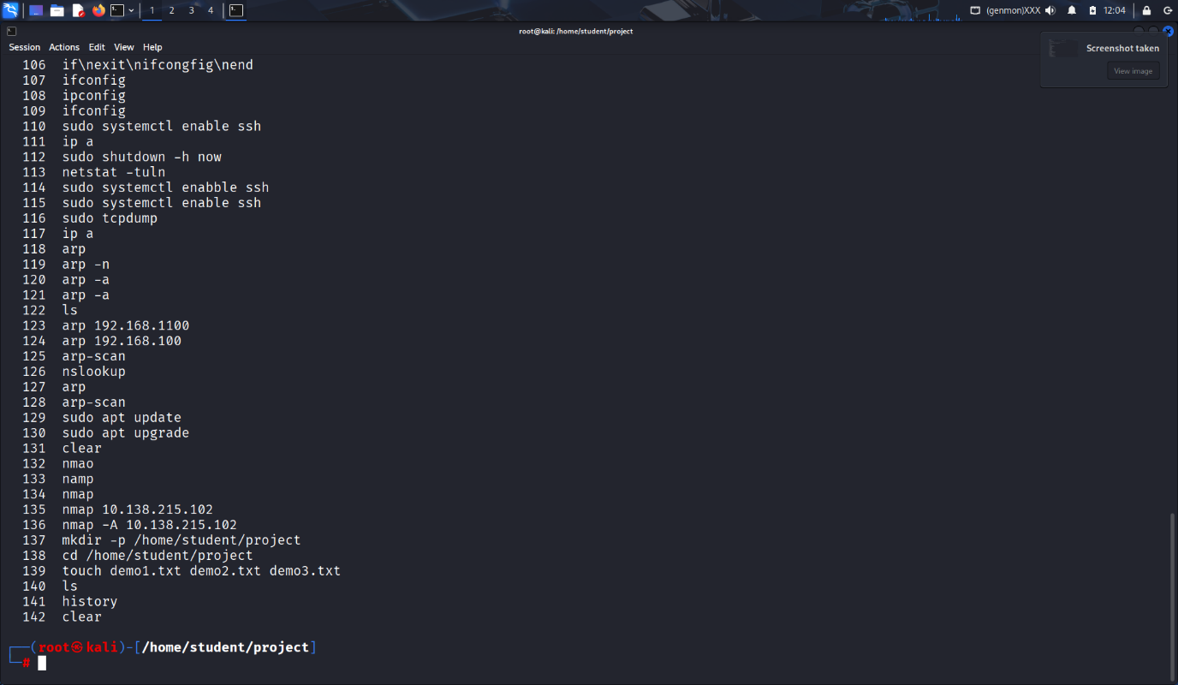
- Compare the working functionality of find and locate command. Which one is faster and why?
Soln:
find command :
The find command searches files in directories.
Syntax: find [path] [options] expression
locate command :
The locate command searches files by name using a database.
Syntax: locate [options] keyword
Faster: locate because it uses indexing.

- Which command is used to modify file permissions in Linux? Give an example.
Soln:
chmod command :
The chmod command changes file permissions.
Syntax: chmod [options] mode file
- A file has permissions -rw -r- -r- -. What does this mean?
Soln:
- Owner: Read, write
- Group: Read only
- Others: Read only
- No execute permission for anyone.

- Explain the difference between chown and chgrp with an example.
Soln:
chown command :
The chown command changes file ownership.
Syntax: chown [options] owner:group file
chgrp command:
Changes group ownership of a file.
Example: sudo chgrp developers file1.txt
- A file needs to be accessible by multiple users but only writable by the owner. How will you set permissions?
Soln:
chmod 644 {filename}
- How do you check the manual page for any Linux commands?
Soln:
man {command name}

